**Everything is pink**

Project Sun Cycle - Germain Spriet

Problem

Objects within the Unity game scene are all showing up as Pink. This is an issue related to the materials or shaders being rendered on the game objects.

Example

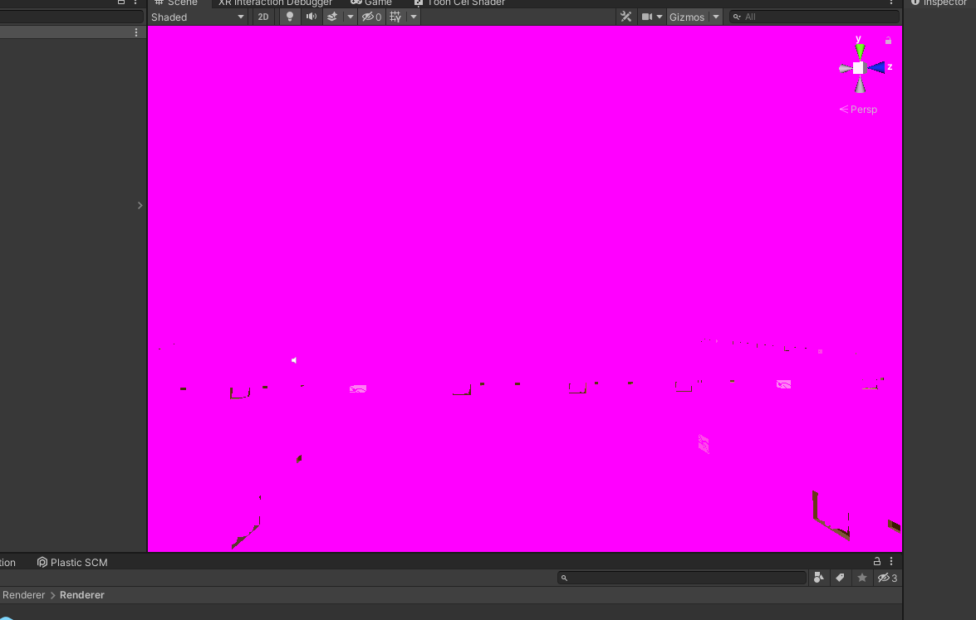

Solution

First navigate to “Edit -> Project Settings...”

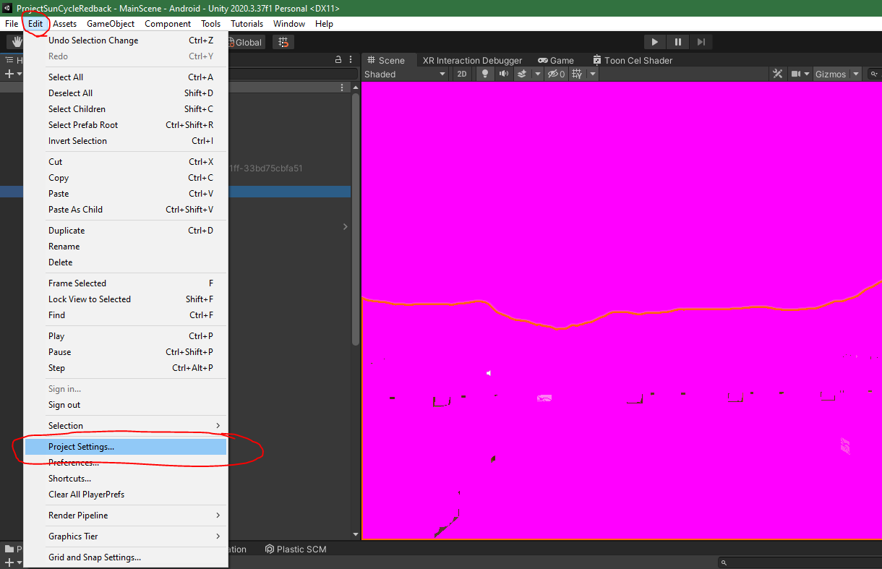

Then navigate to the “Graphics” section and ensure that the scriptable render pipeline is **not** set to “None” by selecting one of the built in unity renderer pipelines.

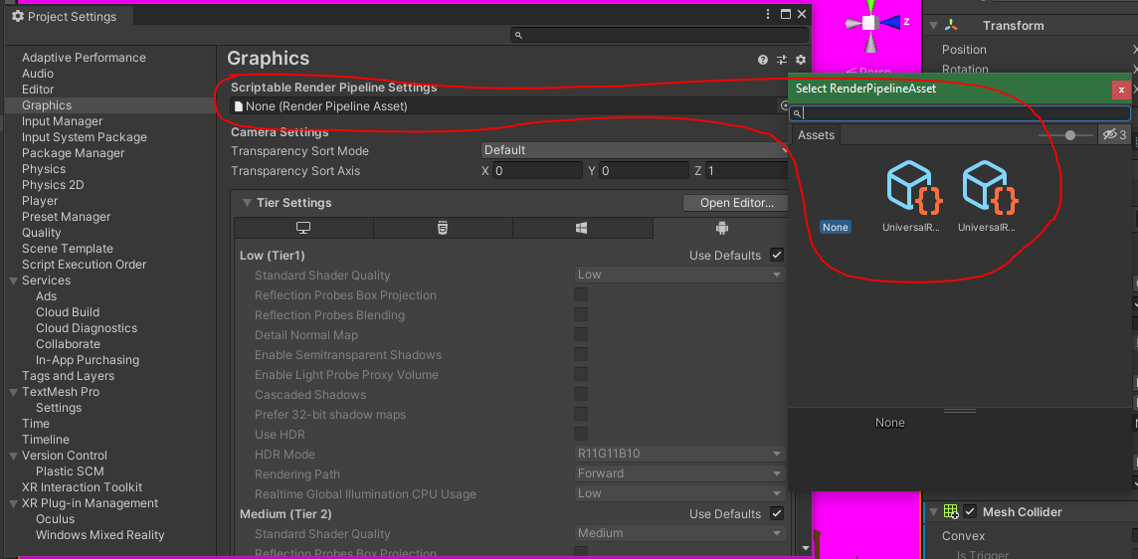

Other possible solutions

1. Navigate to the “Quality” section of the Project Settings and ensure that the “Rendering” field is **not** set to "None".

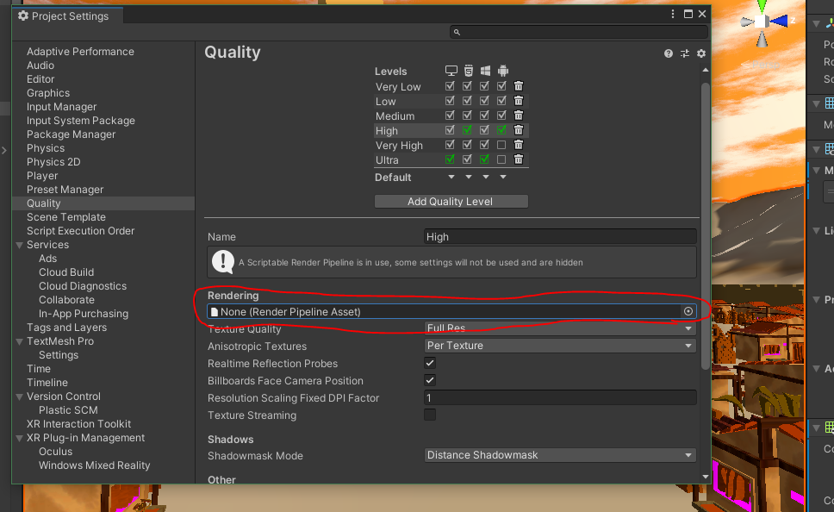

1. Follow the navigation in the image below to Upgrade Project Materials to UniveralRP Materials.

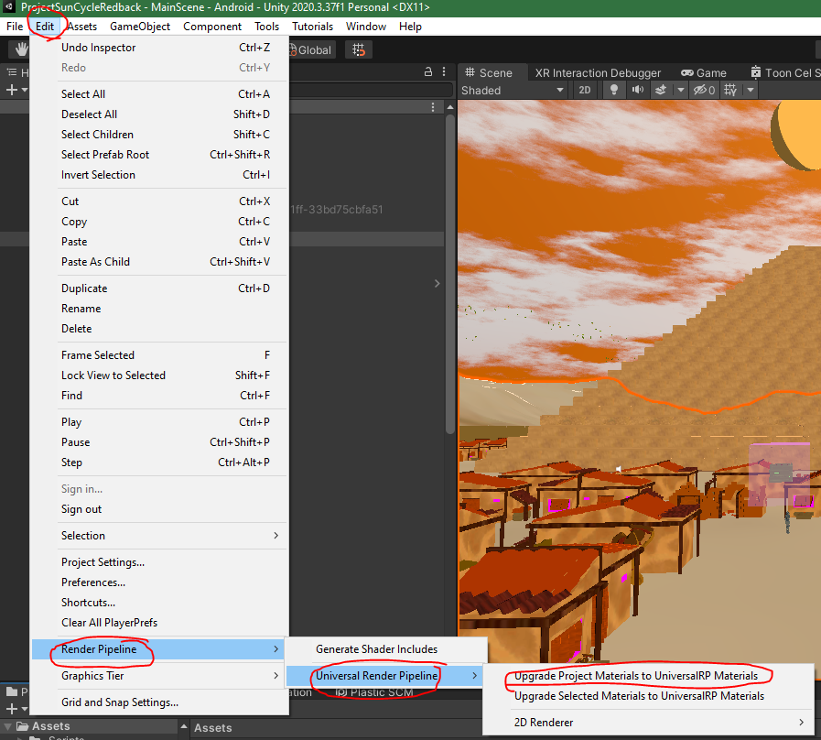

1. As the Sun Cycle project is using a custom made shader (toon cel shading), Navigate in the project directory to “Assets -> Visuals -> Shaders”, then right click the “Toon Cel Shader” and click reimport.

